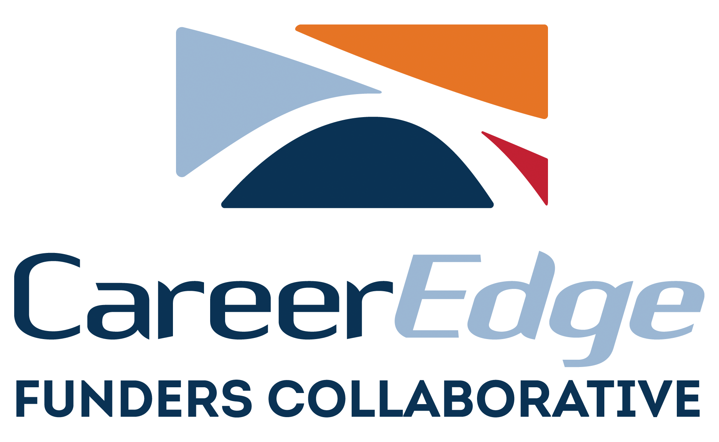

Media Alert

Contact: Mireya Eavey
Executive Vice President
(941) 809-7430

CareerEdge Offers Career Exploration Tool for Sarasota and Manatee County Students

Sarasota-Bradenton, Fla. (March 1, 2021) – CareerEdge Funders Collaborative has updated its “Where are the Jobs?” guide to assist our region’s students and young adults with exploring possible career options. Through colorful graphics, the guide features a listing of the highest demand jobs in the area, along with their average wages, and the educational pathways to obtaining a credential for each.

A generous sponsorship from Bank of America Sarasota/Manatee is funding the printing of the “Where are the Jobs?” guides which will be distributed to schools and community-based organizations throughout the bi-county region. CareerEdge worked with local consultant Deborah Chapman, as well as partners PlanIt Sarasota and REACH Manatee, the local college access networks, to update the career planning resource.

All of the highlighted career pathways, including technical certifications, are considered forms of education beyond high school that lead to career-laddering jobs with good quality wages. Key industries will be unable to find sufficiently trained workers to fill these positions if not enough people earn a credential in these high demand fields.

To view the “Where are the Jobs” Guide click here.

###

About CareerEdge Funders Collaborative
CareerEdge Funder’s Collaborative is an innovative partnership of business, government, and philanthropic organizations that leverages public and private dollars to provide opportunities for better jobs and wages in Manatee and Sarasota counties. CareerEdge is the workforce development initiative of the Greater Sarasota Chamber of Commerce. For more information about CareerEdge and its partners, please visit www.careeredgefunders.org or call 941.556.4029.

About the Greater Sarasota Chamber of Commerce
The Greater Sarasota Chamber of Commerce is a not-for-profit organization that works to cultivate Sarasota's prosperity and quality of life through our member businesses. CareerEdge Funders Collaborative is the workforce development initiative of the Greater Sarasota Chamber of Commerce. For more information please call (941) 955-8187 or visit us at www.sarasotachamber.com.

